Smart Traffic Solution

MD Tashanul Iqbal Sifat   
Computer Science And Engennering Dafdodil International UniversityAshulia,Dhaka, Bangladesh  
tashanul15-1532@diu.edu.bd

*Abstract*—Traffic jam is a major problem in big cities and its not going anywhere soon. The amount of time lost in traffic is sheer in volume and effects heavily on the growth of the country. Controlling a large cities traffic manually buy only the help of traffic sergeant is pointless. So the only way for this to work is to make an automated traffic system that acts accordingly to the traffic of the road at that moment. We tried to make a traffic system that will independently and according to the needs of the road using the length of the jam. We are making an Arduino based project which will detect the length of the traffic jam in each side of the road. We set some conditions, Based on that the amount of time each side has to sit on the traffic will vary. The device will automatically change the traffic lights on the roads, depending on the volume of traffic on the each side of the road. It will help the officer in duty heavily and create a more moving road which will surely move the economy and people lives to betterment.

# INTRODUCTION

Traffic congestion is a condition in transport that is characterized by slower speeds, longer trip times, and increased vehicular queueing. Traffic congestion on urban road networks has increased substantially, since the 1950s.

Traffic jam is a problem in most large cities worldwide. Usually, it is caused by the sudden increase in the number of vehicles on roads during peak hours and bottlenecks in the transportation infrastructure. Even with the continuous improvement of the urban transportation system, the number of vehicles tend to increase as the economy develops. Therefore, road traffic congestion becomes a recurrent problem. Several negative impacts for society are associated with congestion, for instance, economic losses, productivity reduction, and the increase of carbon dioxide emissions as drivers get stuck in traffic.

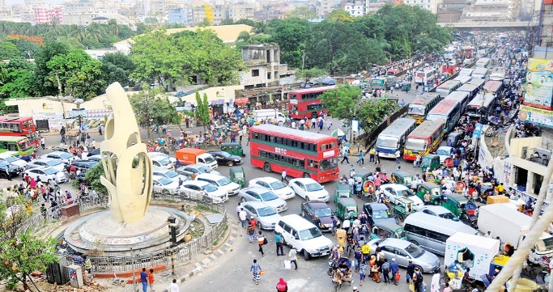

Figure 1 daily picture of traffic jam in Dhaka

So our main challenges is to make a clean automated system which will work as the situation needs. Our project is a Arduino Uno Based embedded system project which uses ultra-sonic sensors as the main components to perceive the length of the jam to analyze the situation and act accordingly. We choose embedded system to implement it to minimize the cost, easy to implement and robust.

We are calling this the **Smart traffic Solution** which will be a automated traffic lights controlling system. This will work as Substitute for the traffic police. We are automated traffic lights will be assisted by subsequent rules which will insure that people abide by the rules.

# MOTIVATION

Rules and regulation isn’t our best suit as the citizen of Peoples Republic of Bangladesh. Traffic system in our country is a mess. Lack of traffic lights, insufficient traffic police, expired vehicles, drivers without license and abysmal roads and highway. Overall we the people are very much the reason and its effecting us in so many levels.

In a country such as ours Dhaka is the capital and also the city which is responsible for the almost half of the GDP. But due to traffic jam, by the government’s own estimate, Dhaka’s traffic jams eat up 3.2 million working hours each day and drain billions of dollars from the city’s economy annually. Our traffic system is abysmal and very outdated. We still depend on the traffic serpents and have only 60 traffic light throughout the cities.

Not only its effecting out GDP growth as mentioned before but also due to traffic jam the growth of the country is hampered. Dhaka is rated 137th among 140 major cities. Which is a very big warning.

During traffic jam the amount of carbon emission is very high which has led Dhaka to be the number one city in the ranking of cities with High Air pollution.



Figure 2 Air pollution chart for major cities

To add to this problems , for not having enough traffic lights and traffic police leads accidents which is a toping over the already dangerously massive by accidents rate of our country. More than 5,000 casualties in road accidents across Bangladesh in 2019. All this things considered it was high time that we did something about it.

# OBJECTIVE

We have set ourselves some objectives for this project which we believe is achievable.

The objectives are as follows:

* To scheme a intelligent traffic monitoring method
* To scheme a intelligent traffic monitoring method without being too expensive which will make it hard to materialize.
* To scheme a project which will greatly increase the comfort and satisfaction of the people on the road.
* To increase the productivity and revenue of the country.

# EQIPMENTS AND ITS DESIGN & IMPLEMENTATION

For this embedded project we used simple components so that we could demonstrate it in a way we could handle. The equipment’s are:

1. Arduino Uno
2. Ultrasonic Sensors
3. Breadboards
4. Connecting wires
5. Led Lights

The Design is simple. Ultrasonic sensors are placed on the breadboard in two sides to represent to sides of the road. Led lights are used to represent traffic lights. Arduino Uno is used to control the whole thing. Connecting wires are used to connect the components in the breadboard and in the Arduino.

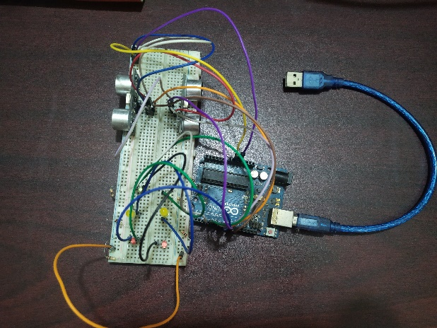

Figure 3 components used in our project

# WORKING PROCEDURE

The main Principle of the device we are building is, Using ultrasonic sensors we will calculate how far the jam has gone and give signals to the traffic lights to take measures against it. This will be implemented in junctions in major intersections throughout the city.

Our prototype project is imagined in a two way road where only one side of the road can pass through at a certain junction. The Ultrasonic sensors will be placed at a certain distance in the road from the starting of the junction. The distance will be a unit where if the jam reaches we can say it’s a massive jam and people have waited long enough. Let’s say in the highway the jam length has crossed 500 meters, where supposedly our sensors are placed. We are calling this the **threshold distance**. It’s the distance which is long enough to know that this jam is imposed for long enough. So the ultrasonic sensor placed there is going to pick up the obstacle in front of it which is the car on the road. Now, you may think it can detect something which is outside the road like and street walker. But the sensors are programmed to in a manner that the maximum length it can pick up things is the width of the road. So that it will not pick up anything as obstacle which is not a car.

Once the Sensors pick up that a jam on the road has crossed the threshold distance than it will automatically stop the other side if the other side didn’t have a traffic jam with the length which crossed the threshold distance. And open the road.

So in a normal circumstances the traffic lights of both sides are going to switch colors in an interval of 6 seconds, 3 seconds on each side. But if a situation arises in one side, the jam increases the length of the threshold distance then it will tell the system and the system will go to **crisis mode**. In crisis mode the system will open the jam-packed road for 10 seconds and keep the other side closed for the duration. Mind you this will work if and only if the other side does not have traffic jam that exceeds the threshold distance. If both sides have Traffic jam that exceeds the threshold distance the system cannot do anything about them and will work regularly.

The Time is a metaphorical and experimental time and is not used to be implemented in real life.

Its programmed in a way so that if the jam in one end doesn’t reach the length shorter than the threshold distance, meaning if the sensor keeps picking up obstacle even after the extended 10 seconds of green lights and if the other side of the road still doesn’t reach a jam bigger than the threshold distance than the timer will extend the green lights for another 10 extended seconds and continue to do so.

It will check every 10 seconds in the crisis mode if the jam has shortened where the sensors can’t pick up the signal. If and when the jam becomes short enough so that the sensors can’t pick up any obstacle than it will turn off the crisis mode and return to regular timing of 3 seconds on each sides. And if by the time the crisis mode on one side finishes and on the other side reaches a jam crossing the sensors than it will start a crisis mode on that side. In this process if both sides faces sensor pick up the system can’t do anything and continue to regular scheduling of 3 seconds delay.

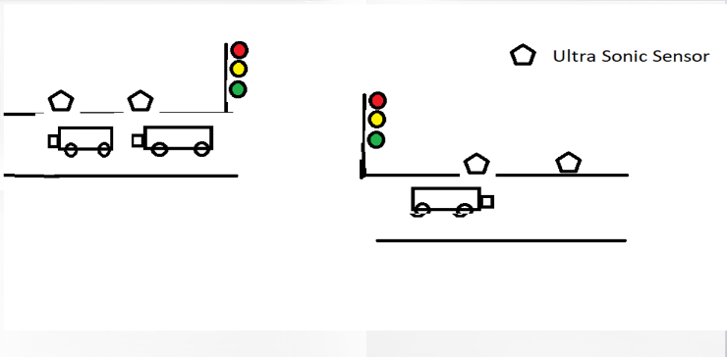

Figure 4 The road we imagined where the device will be implemented.

# GOALS AND OUTCOME

We are very much passionate to make a project which will help in the betterment of our country. our countries progress. As a Third world country we owe our country to contribute in a way so that we can lead in the world in a positive way. Here are the goals of our project.

* Minimizing the traffic police work load
* Reducing accidents due to road junctions.
* Reducing sound pollution due to vehicle horn and to minimize the air pollution.

# LIMITATIONS AND TECHINAL DIFICULITES

We are disappointed to say we couldn’t implement everything that we imagined for this project. There was a lot of first times for us and we hope we can only go towards achieving more in the coming days. The Limitations we faced are:

* Till now we are limited to barricade the vehicles automatically for safety purpose.
* It is an automated setup, so it could give wrong information’s sometime.
* Till now we are not friendly to these type of technology.
* We did not get the best sensor to implement the project with higher potential.
* We were unable to use multiple sensors to compare the jam on both sides for their actual length. But for budget issues we used two sensors which allowed us to take just a common spot to compare the length of the jam.

The Technical Difficulties are as follows:

* We faced difficulties in selecting the correct sensor.
* Detecting of actual position of the tail of traffic jam was very hard to do.
* Connecting the wires and handling the Arduino for the first time was difficult.

# Conclution

This project was a lot of first for us and we were confronted with a lot of challenges. There is a lot of room for improvement. But we have good hope that this project will be something very special which will all can be proud of. And we will work with perseverance and tenacity to achieve this goal.

# REFERENCE

1. https://www.aa.com.tr/en/asia-pacific/bangladesh-alarming-rise-in-road-crashes/1692643#:~:text=In%202019%2C%20deaths%20in%20road,crashes%20in%202018%20in%20Bangladesh./
2. https://www.nytimes.com/2016/09/23/t-magazine/travel/dhaka-bangladesh-traffic.html/
3. https://www.iqair.com/us/world-air-quality-ranking/
4. https://en.wikipedia.org/wiki/Traffic_congestion/
5. https://www.dhakatribune.com/bangladesh/dhaka/2018/05/20/study-dhaka-traffic-wastes-5-million-work-hours-costs-tk37-000-crore/
6. https://www.maxbotix.com/articles/how-ultrasonic-sensors-work.htm/
7. https://www.allaboutcircuits.com/technical-articles/understanding-arduino-uno-hardware-design/
8. https://www.arduino.cc/en/Guide/ArduinoUno/

s